Frequent Subgraph Discovery
Michihiro Kuramochi and Georage Karypis
The 1st IEEE Conference on Data Mining, pp. 1-14, Aug. 7 2001
Abstract
In our problem setting, we have a dataset of transactions D. Each transaction t∈D is a labeled, or colored, undirected graph. Edges and vertices have their labels, or colors. Give a minimum support %, we would like to find all connected undirected subgraphs that frequently occur in at least 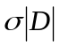 transactions.
- Introduction
Notation | Description
D | A dataset of graph transactions
t | A transaction of a graph in D
k-(sub)graph | A (sub)graph with k edges
g^{k} | A k-subgraph
C^{k} | A set of candidates with k edges
F^{k} | A set of frequent k-subgraphs
cl(g^{k}) | A canonical label of a k-graph g^{k}
- Frequent Subgraph Discovery
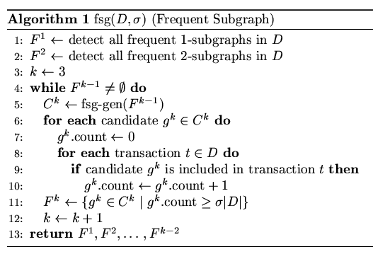

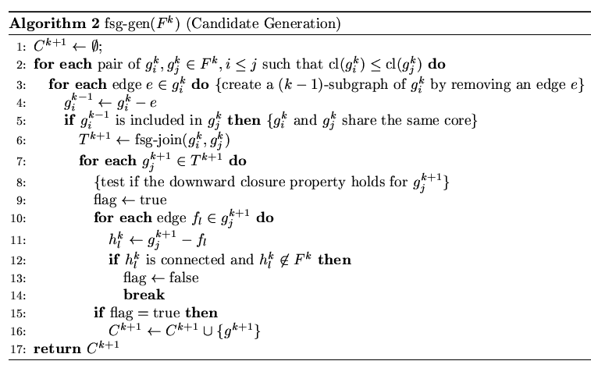

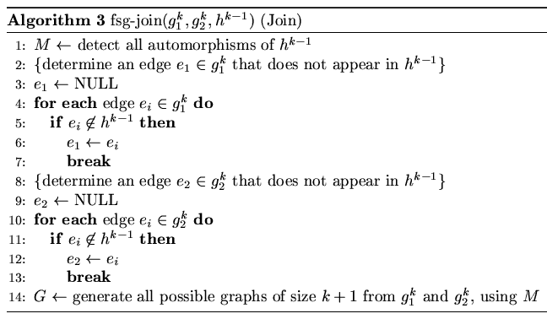

2.1 Canonical Labeling
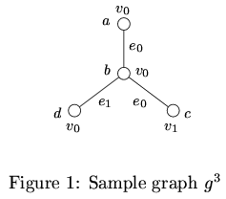
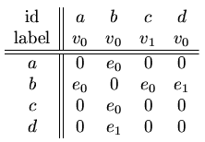

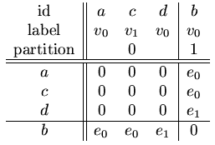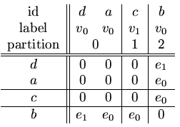

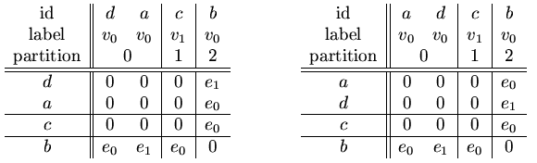

Code = 000e₁e₀e₀ Code = 000e₀e₁e₀

∵ e_{1 <} e₀ and to compute a canonical label of a graph, we have to try all the permutations of its vertices to see which order of vertices gives the minimum adjacency matrix.

∴ cl(g³) = 000e₀e₁e₀

The reduced search space becomes 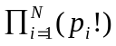, although the original was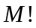.

2.2 Candidate Generation
We create a set of candidates of size k+1, give frequent k-subgraphs. Candidate subgraphs of size k+1 are generated by joining two frequent k-subgraph. In order for two such frequent k-subgraphs to be eligible for joining they must contain the same (k-1)-subgraph. We will refer to this common (k-1)-subgraph among two k-frequent subgraphs as their core.

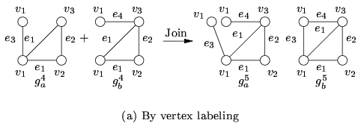

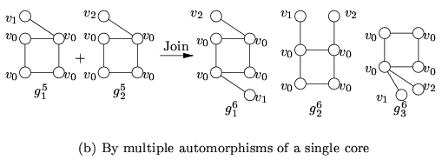

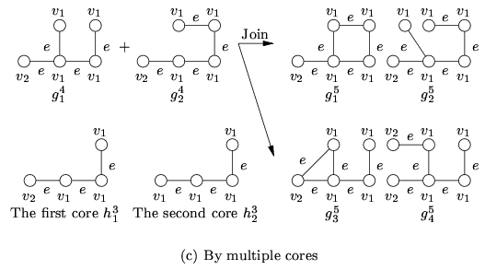

Figure 2: Three different cases of candidate joining
Example:

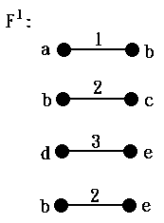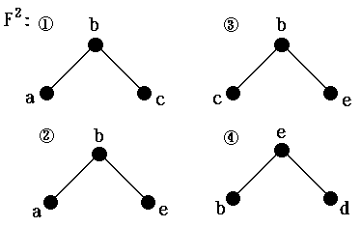

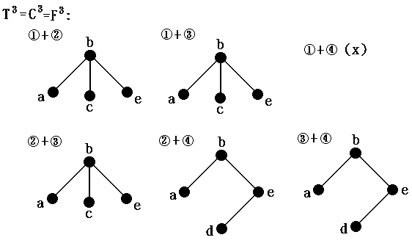

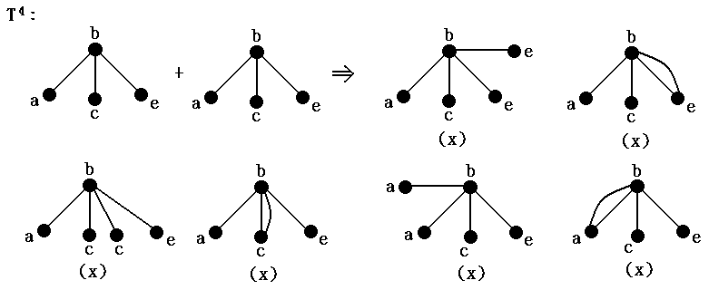

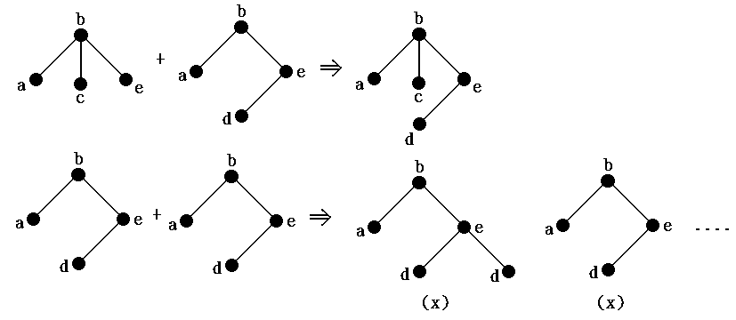

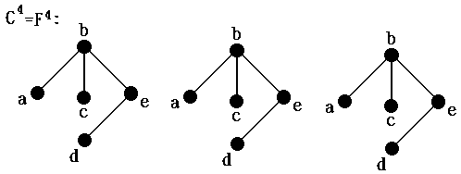
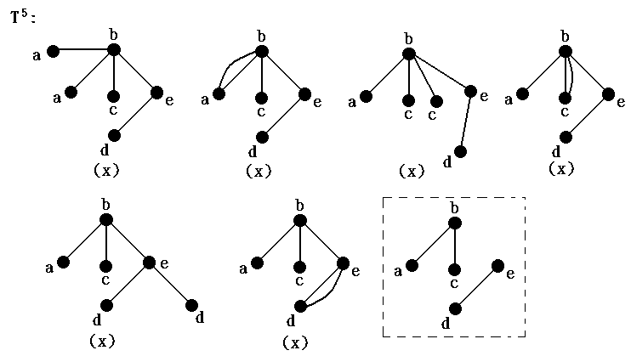

C⁵ = ∅ ⇒ F⁵ = ∅
Created by : Meng-Yi Wu
Date : Nov. 29, 2002

